Protect that Dolphin

Need 6 fuse holders, 6 ea AGC1 fuses.

Install 4 in the Dolphin and 2 in the gray junction box.
Take a look at the charger board. It has a 13 pin connector on it
with a harness that leads to the connector at the back-center of the
main board. Notice the pattern of the wires in the charger connector.
(1)--(4)--(7)(8)-(10)(11)(12)(13). The dashes are empty. Start
counting from the position that is closest to the front of the
truck. Add 1 amp, 250vac fuses to positions 1, 4. Then add 1 amp fuses to positions 7, 8. One and four is the AC voltage
going to the main board. Seven and eight is the pwm that goes from the
main board to the charger.

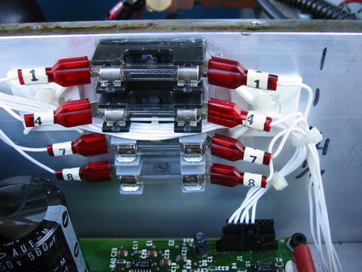
Or

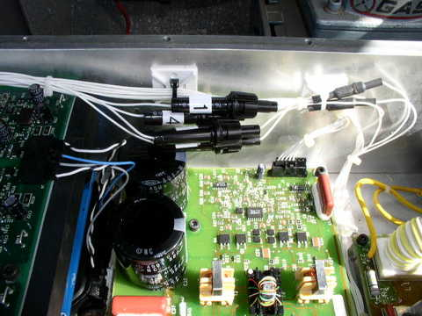

The last two, 1 amp fuses go in the junction box. One comes
from the KEY switch and CP, because the charge port
also can send wild +12V into the Dolphin.

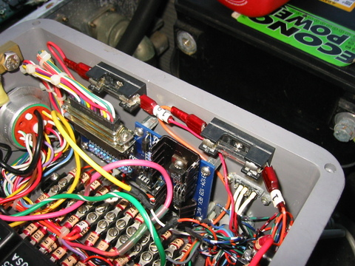
Or
