Well now that my warranty has expired on my robo mower I feel safe in taking it apart to see how it works. This is not to be taken as an attempt to encourage anyone to take apart their own mower. I assume we are all adults reading this and aware of the risks involved in unfamiliar undertakings. I found that there are ten black plastic connectors holding the top onto the bottom.

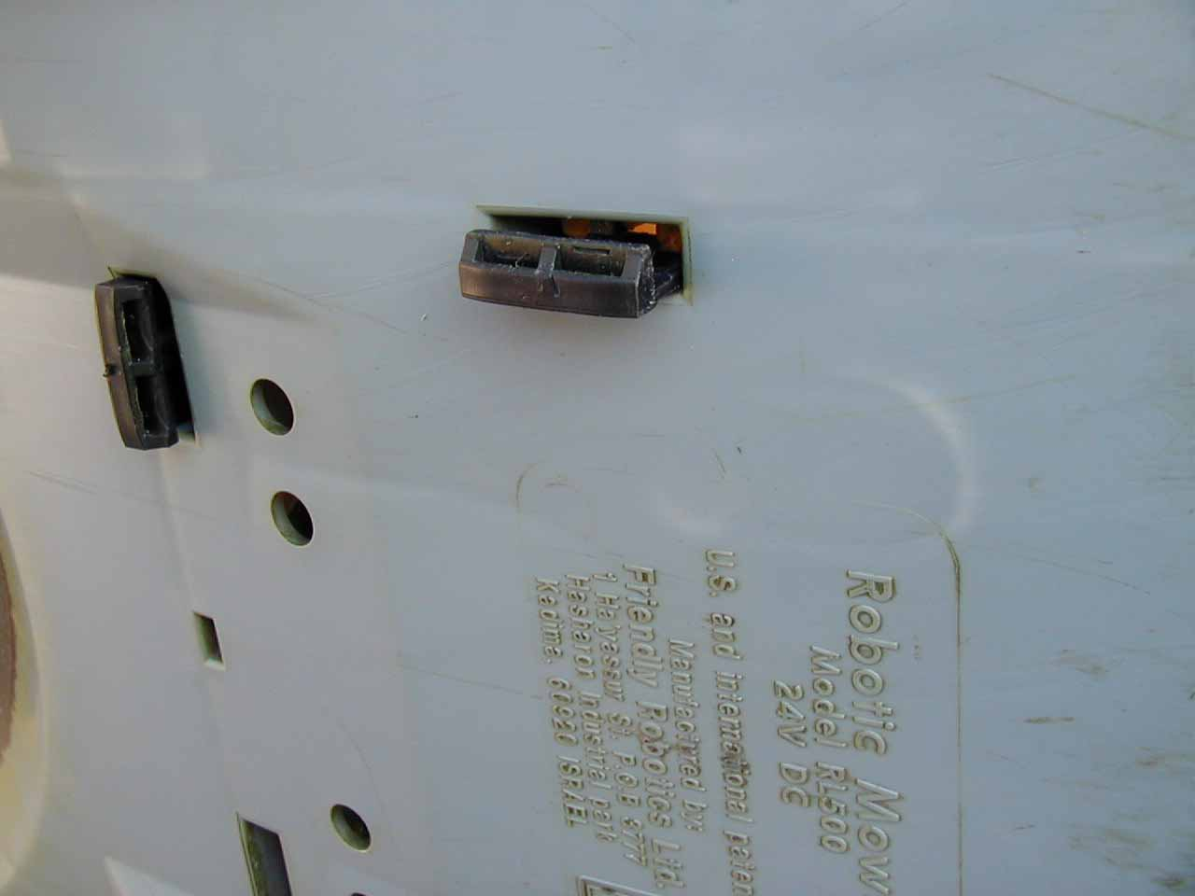

These can be pried out with a screwdriver. After all ten of the plastic connectors are pried out you can remove the top. This should be done very carefully as the top is connected to the mother board with a ribbon cable and there is very little slack. Slip the ribbon cable out of the white cable holders. Next disconnect the cable from the motherboard. The top can then be placed aside. You can see the connector board and the ribbon cable in the picture below.

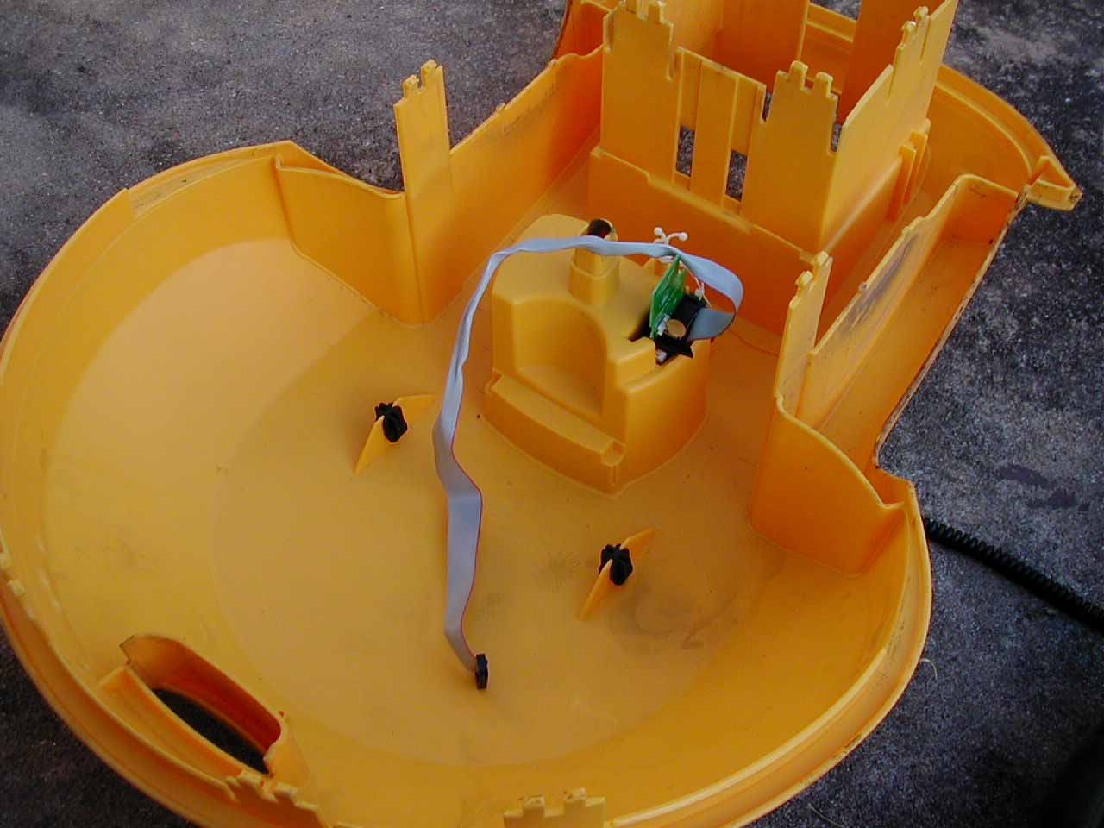

Once the top is removed you can see all three of the mower motors and the two drive motors as well as the motherboard.

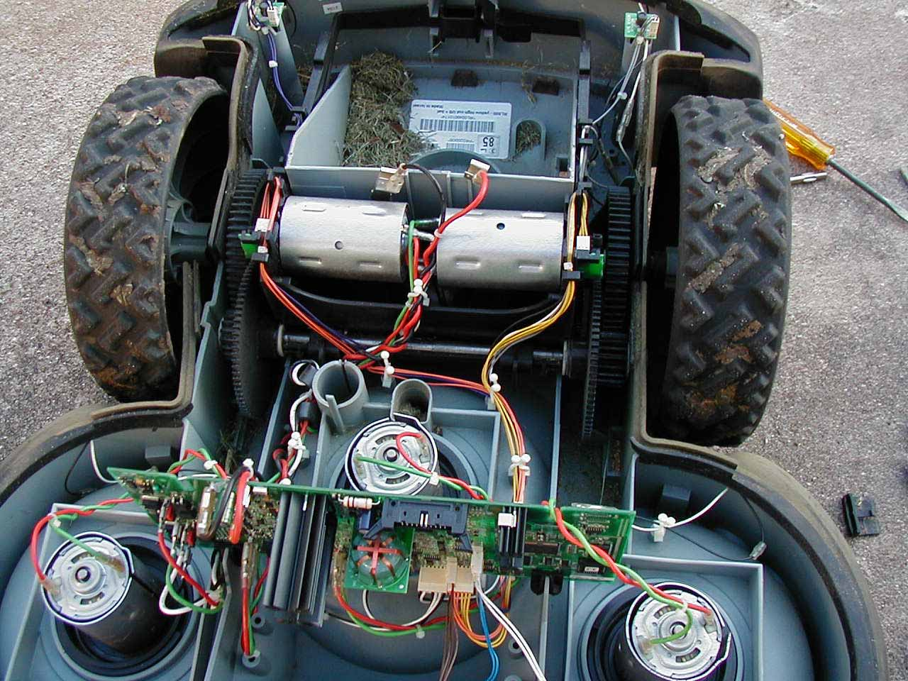

From the picture above you can see the ribbon cable connector at the center top of the motherboard. It is keyed so you cannot put it back in the wrong way. Strange as it seems the red stripe that normally indicates pin 1 is on the opposite side from what is marked as pin 1 on the motherboard. Just below the cable connector and a little to the left is an interesting device. I wonder if this is a compass?

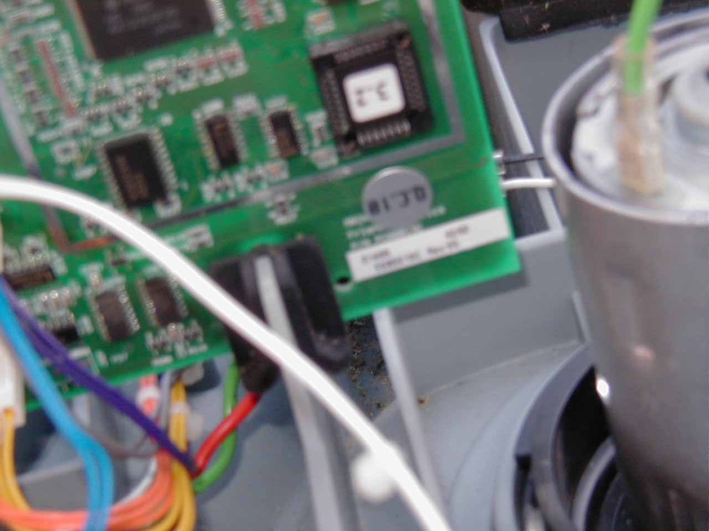

What appears to be the EPROM can be seen on the right bottom of the motherboard and it appears that I have version 3.2.

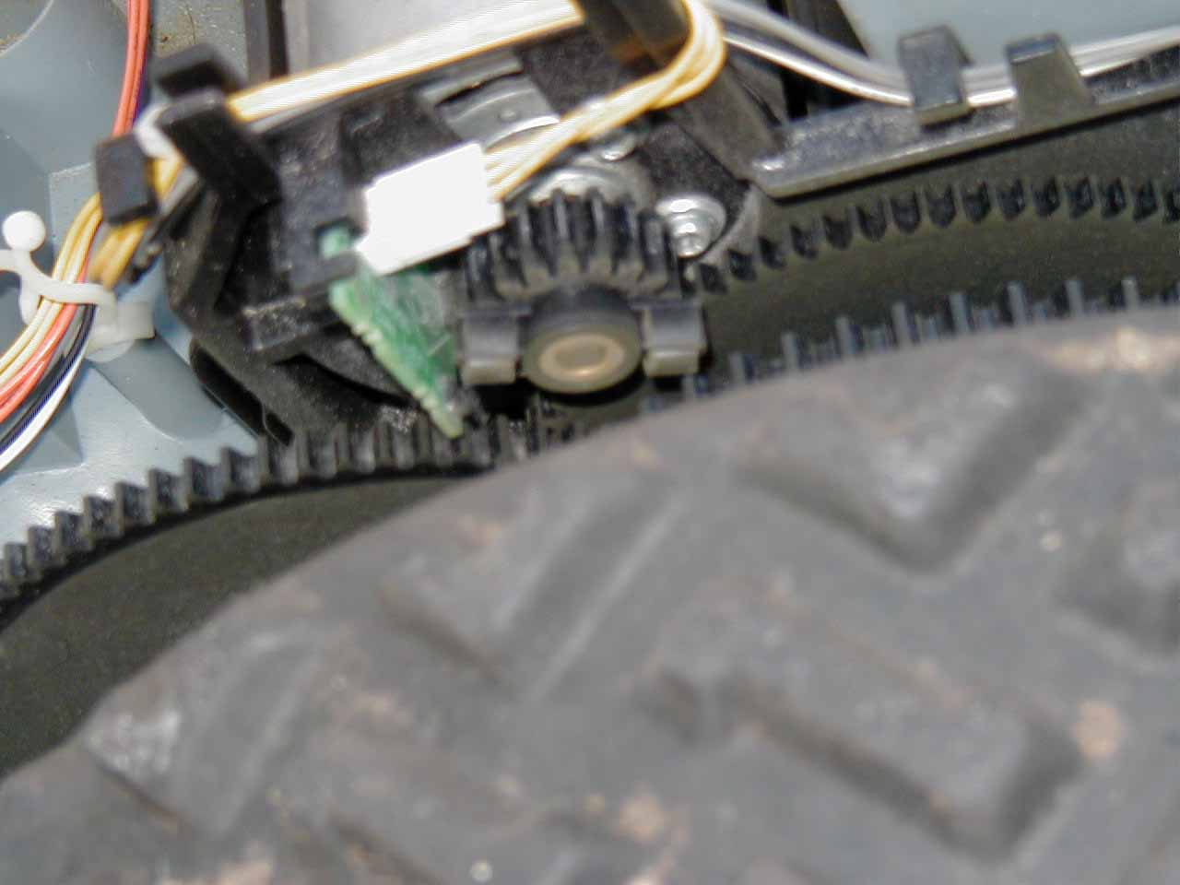

Each drive motor has an odometer made up of a circuit board with sensors and a two part signal device on the end of each motor. The drive gears seem to be nylon and the teeth appear to be in good condition so I am left with no apparent reason for the slight ticking noise when the mower reverses. Of course I could have easily overlooked something obvious. If it gets worse it will probably reveal itself to me anyway. If not then I guess I can live with it. The gears do not have any lubricant and I guess this is a good idea as it would most likely hold dirt and grit and wear out the gears faster. I know some dirt gets in the case as I found some grass clippings inside it in a couple of places.

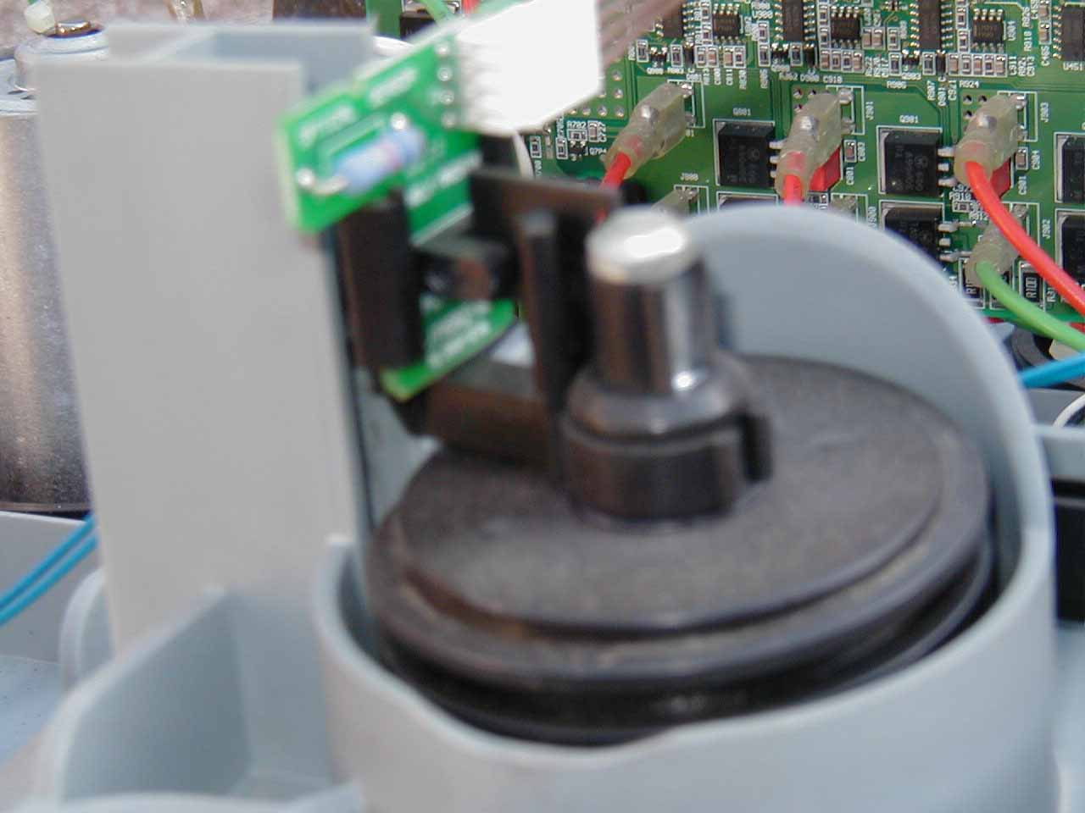

Front wheel position is sensed by the front wheel position switch above. If the mower front is lifted the wheel drops down and the switch closes.

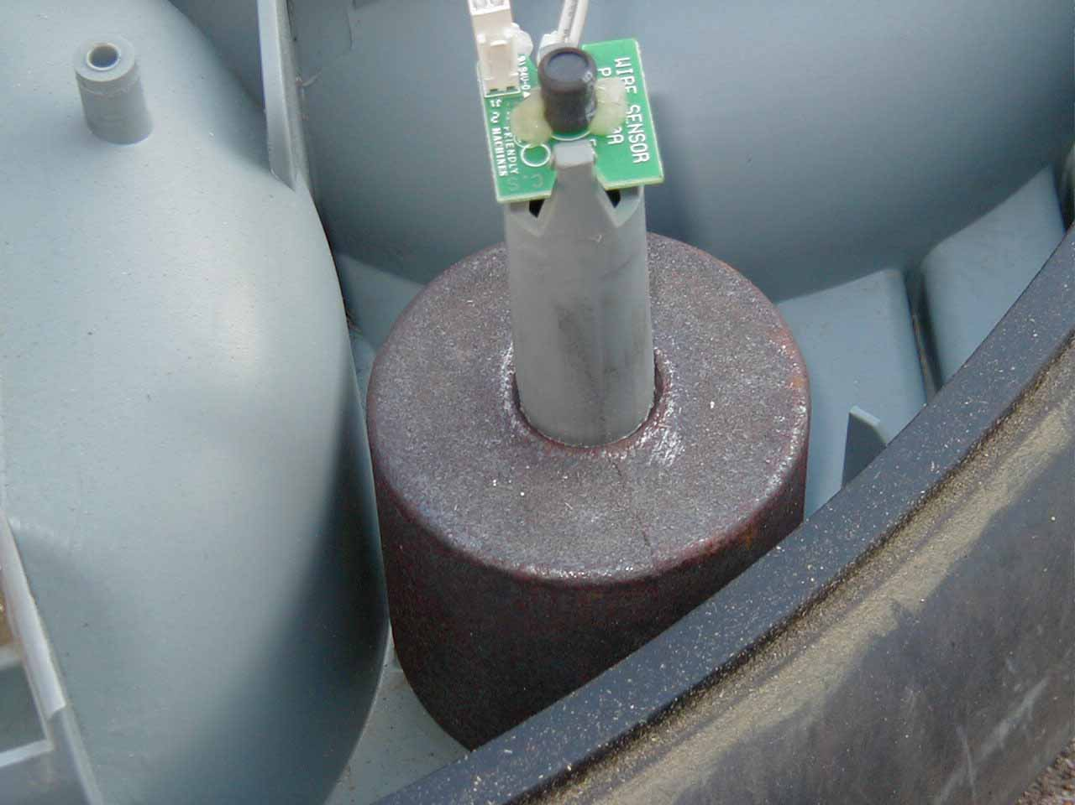

The mower has four wire position sensors. Two in front and two in back. A front wire position sensor is shown above. A rear wire position sensor is shown below.

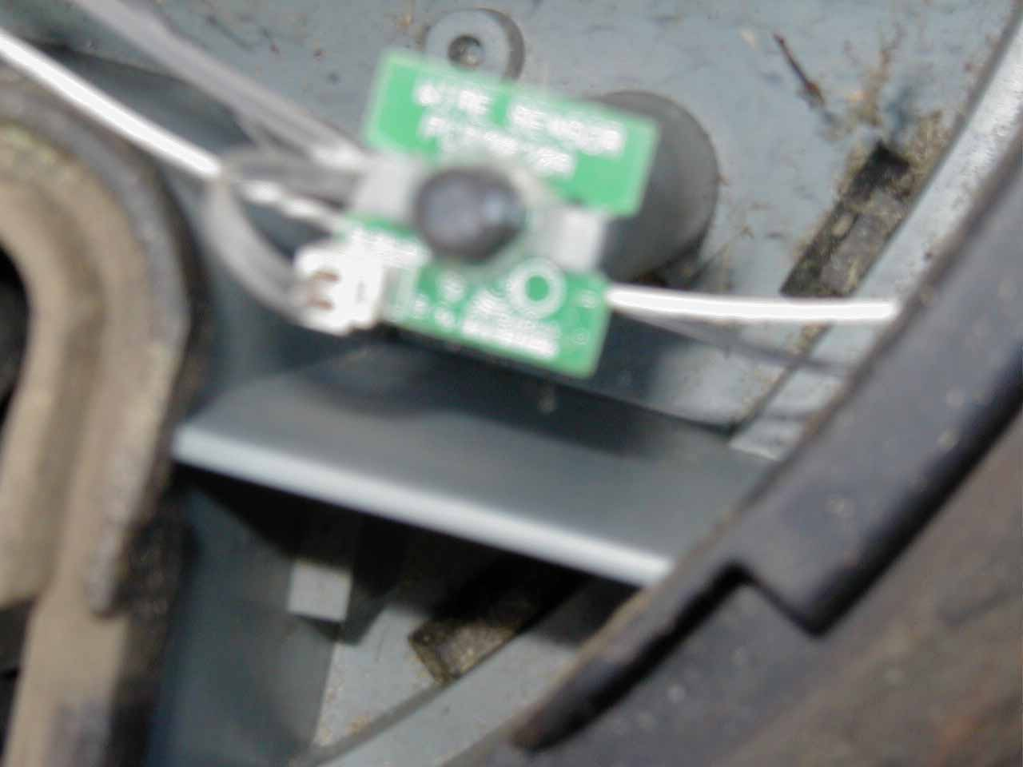

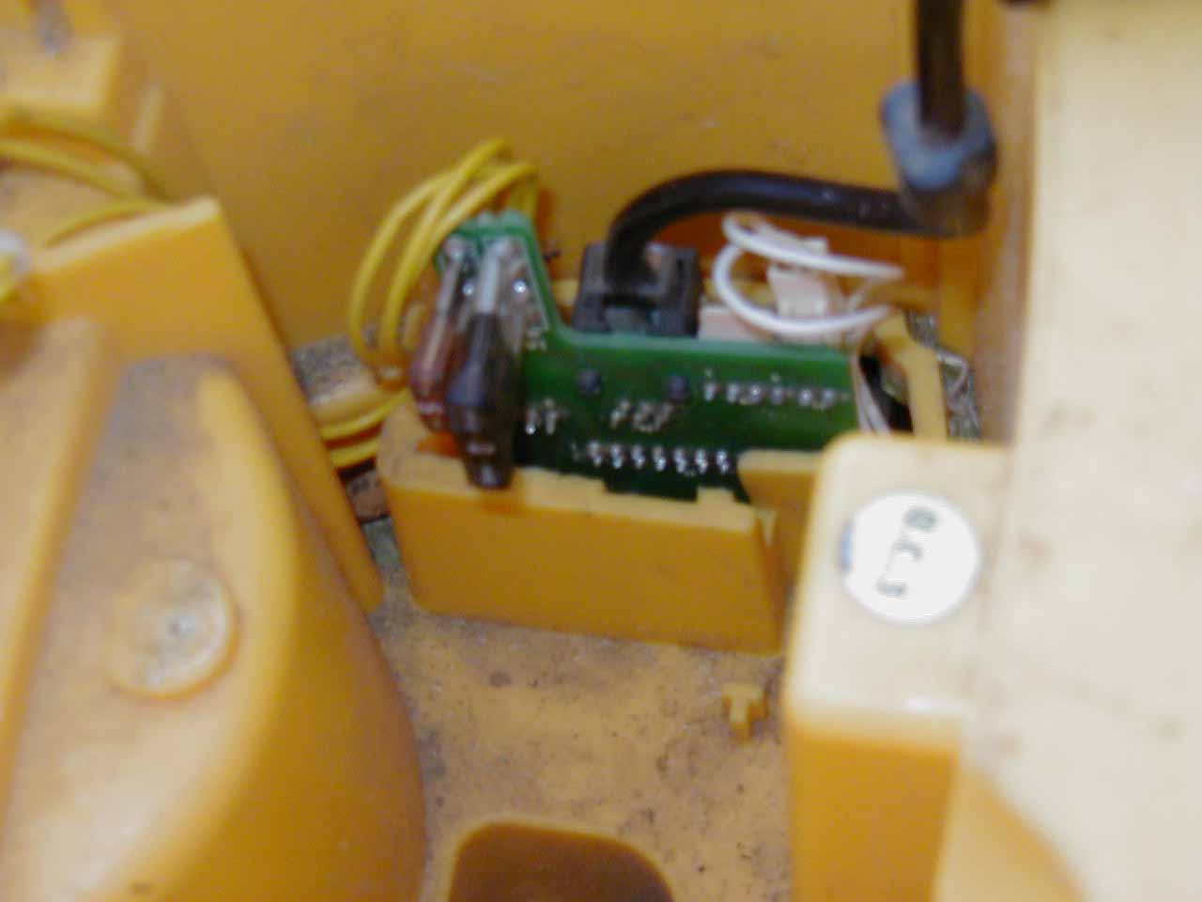

Above is the connection board with the cover removed. It is a good idea to remove the cover when putting the top back on the mower to help in guiding the connector board into the hole in the lower body. Putting the cover back on the connection board was very frustrating. Two automotive type fuses are on the connection board, one five amp and a one amp. Just to the left of the white connector with the white wires is a four pin connector with no wire. This would be enough wires for a serial connector or even possibly a USB connector. I will investigate this connector later for voltage levels and polarity to see if I can determine what type of port if any that this may be and if I think I have it worked out maybe try to connect a PC for a little snooping to see what I can see.

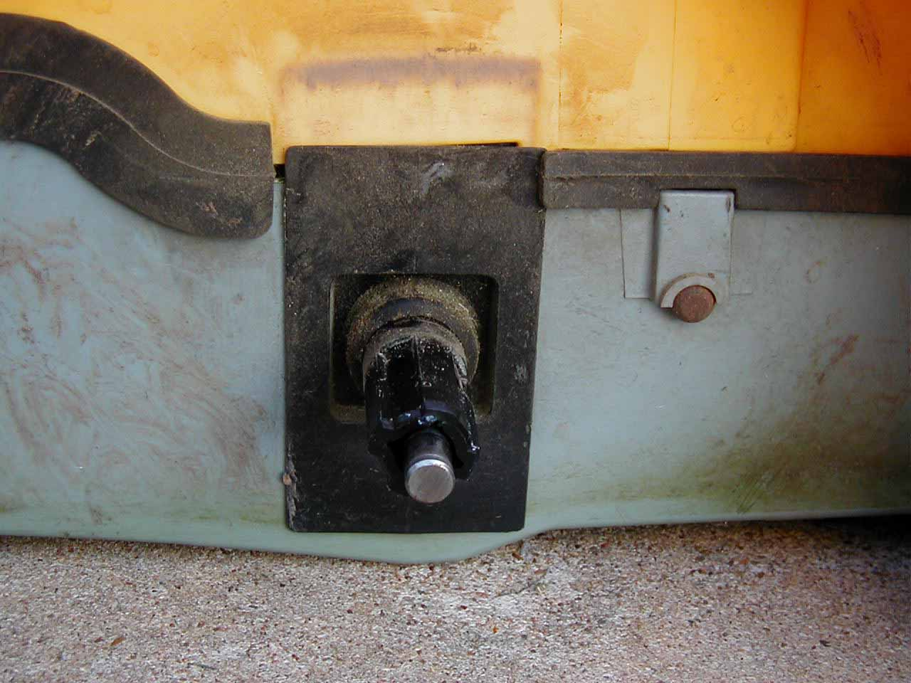

From the stains on the case, in the picture above it would appear that a rubber seal was in place above the axel at one time. This has been apart once for repairs so that is a possibility. It is a good idea to remove the wheels before putting the top cover back on as the rubber seals are not easy to keep in place and you want positioned properly to keep out as much dust and water as possible.

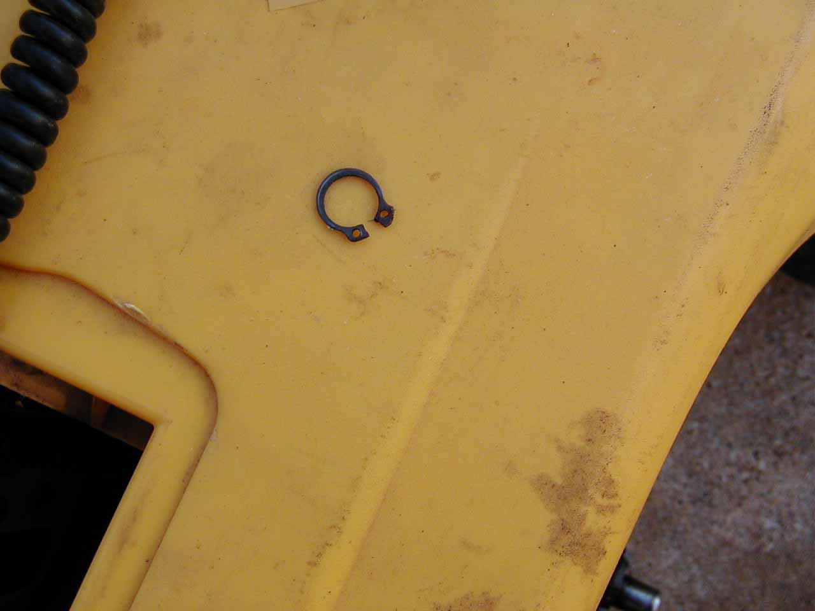

The wheels are held on by snap rings. You will find they are much easier to remove if you use snap ring pliers to remove them.

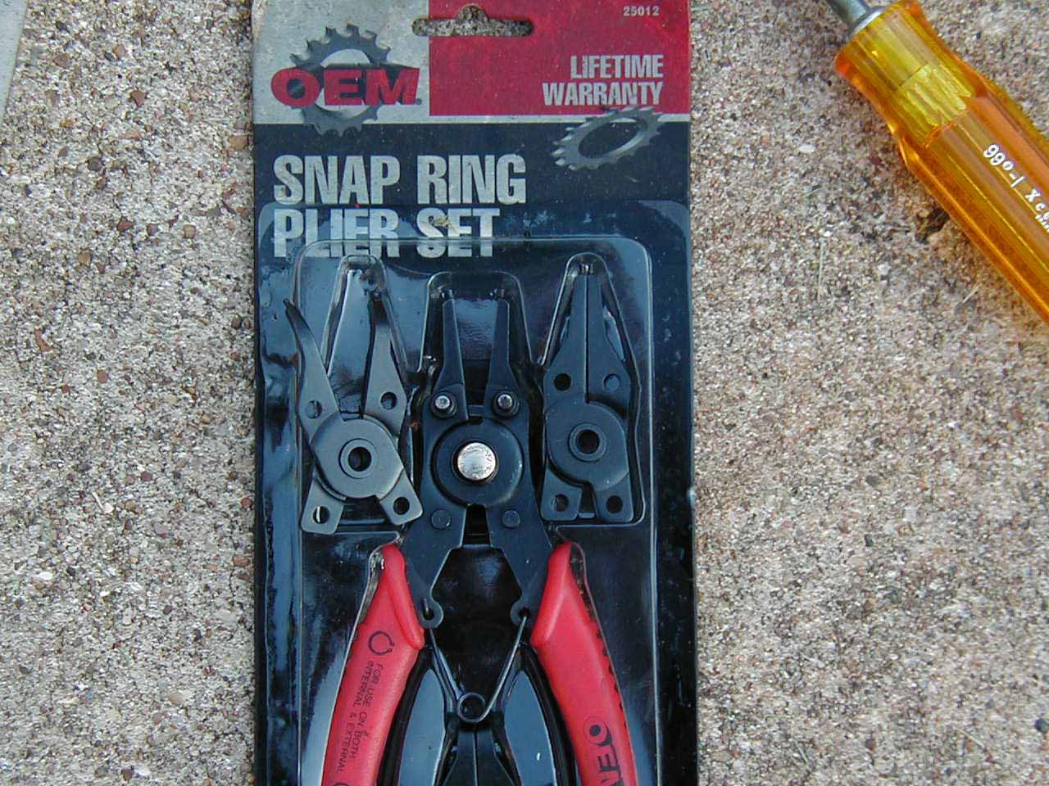

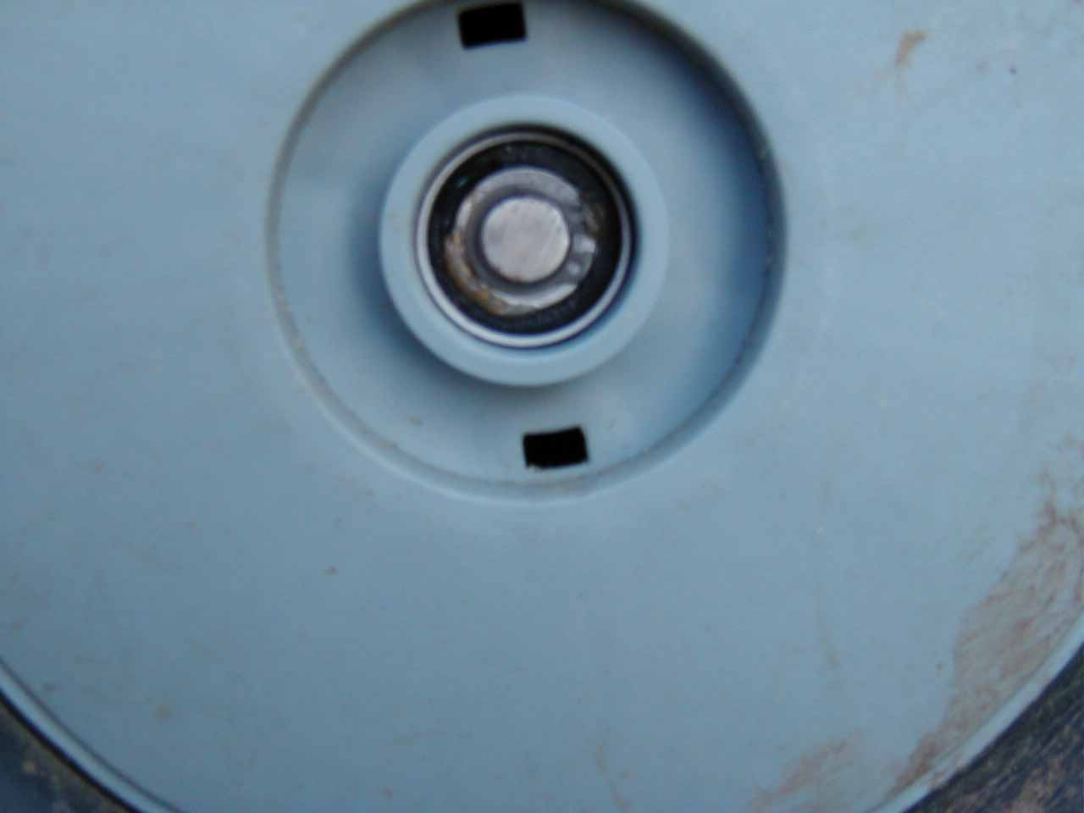

The picture above is the wheel with the little hub cap removed. Be careful not to step on the hub cap as they break easy. I almost broke one when I stepped on the edge of it.

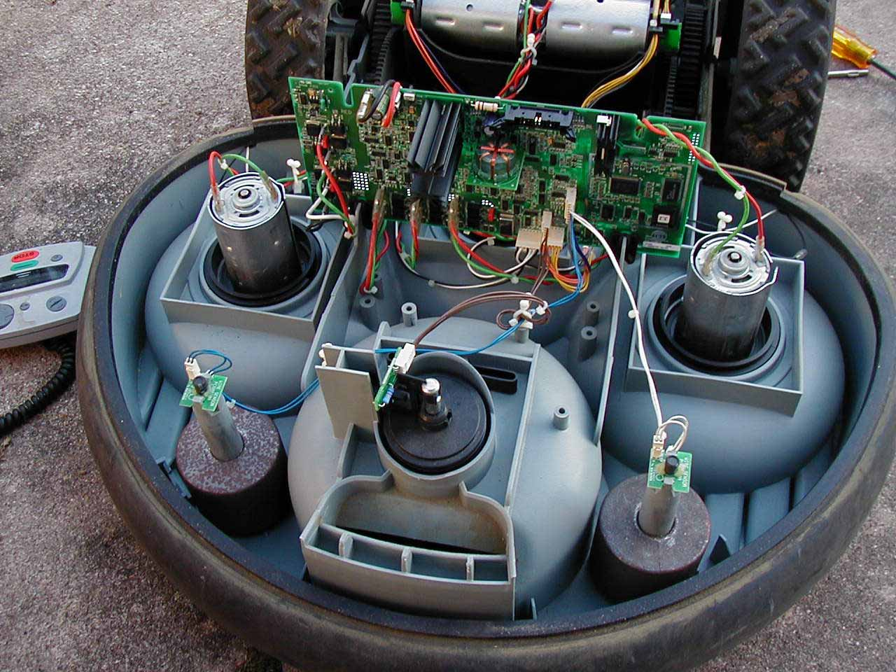

Above you have a better view of the front wire position sensors and the front wheel position switch.

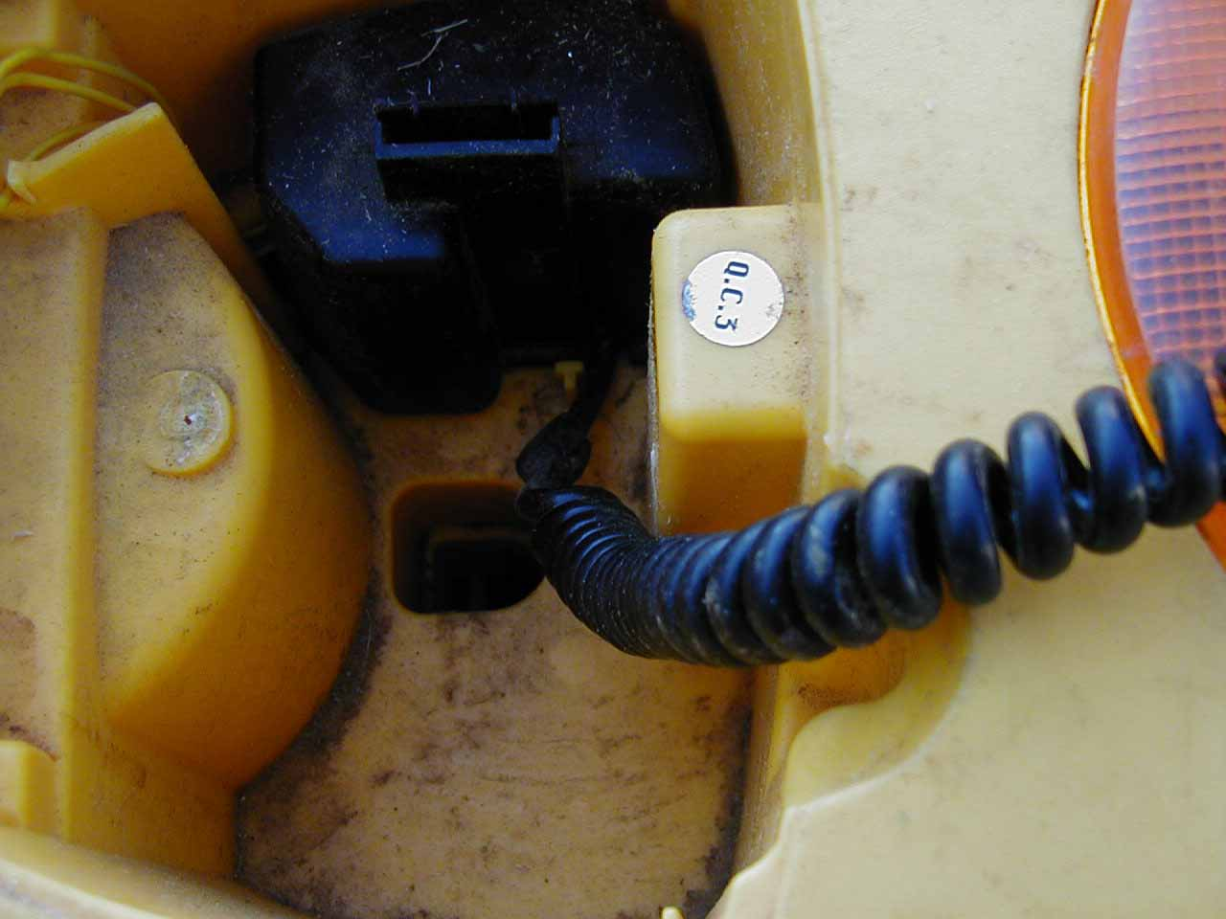

Above is the connection board cover that was so hard to snap back in place. I can see where many repair techs may send it back loose.

