To upgrade the mower software
There are two methods to get to the flash chip that needs to be replaced for a software upgrade.

Remove the left blade mower
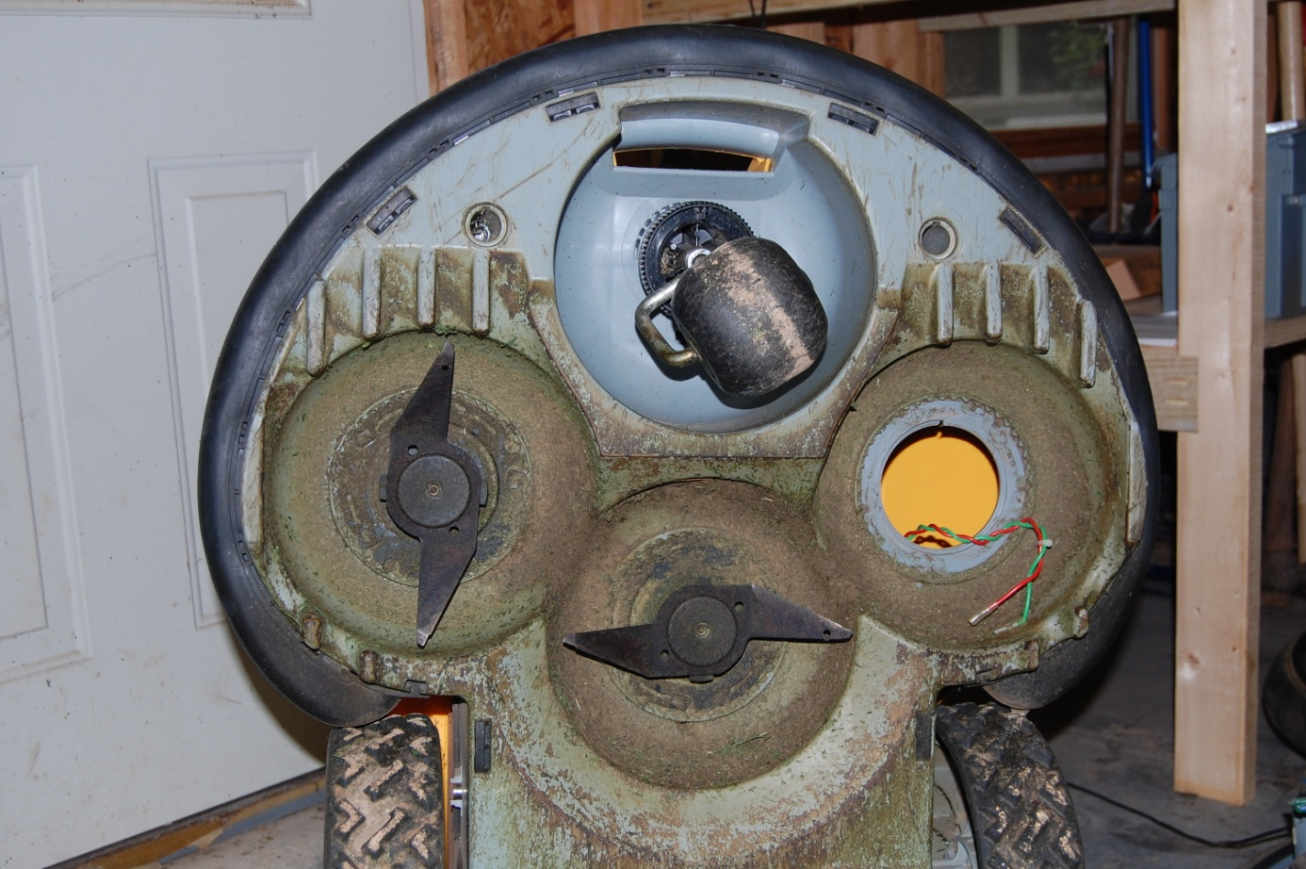

The flash chip is located on the corner of the mainboard that is closest to the opening
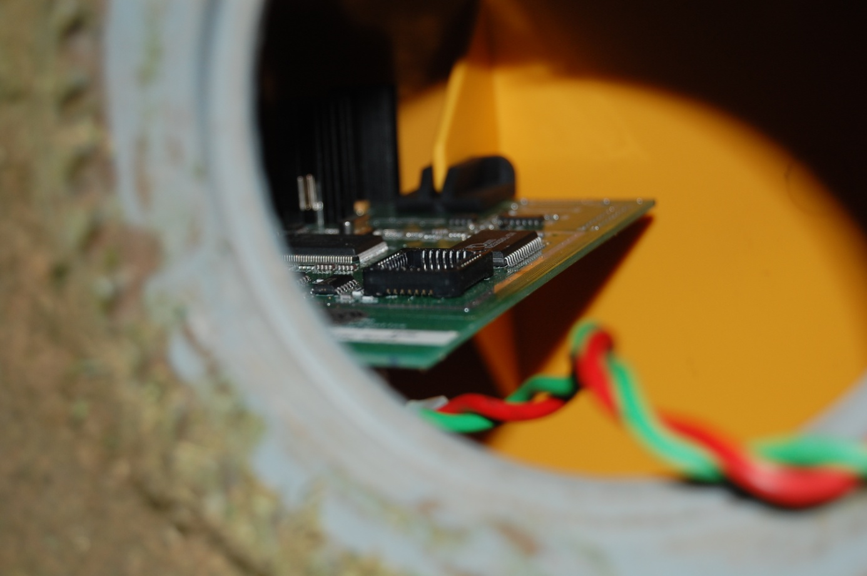
See the next section for guidance on removing the chip

Remove the mower cover
Detailed removal instructions are provided in the Yahoo Groups file section
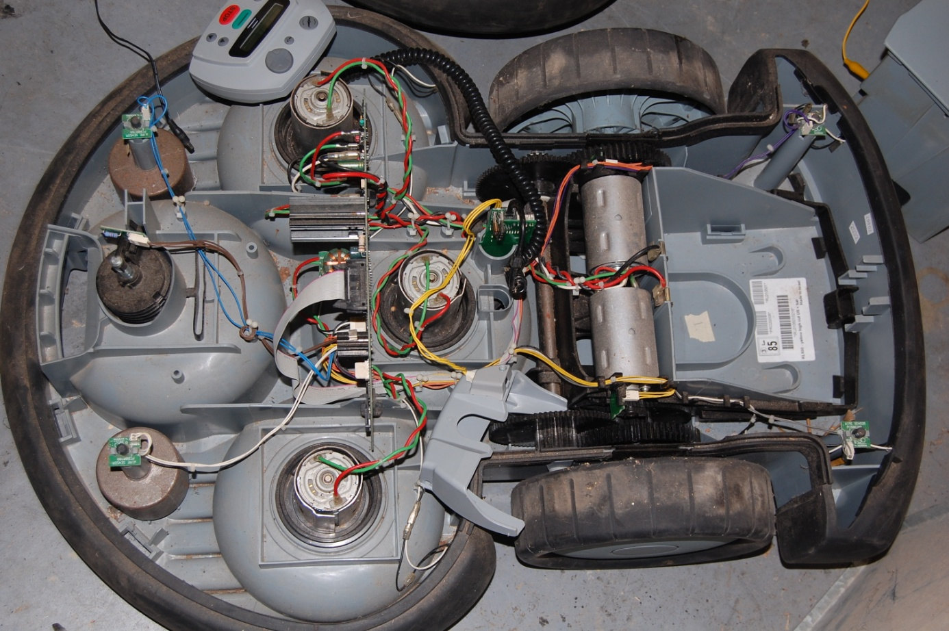

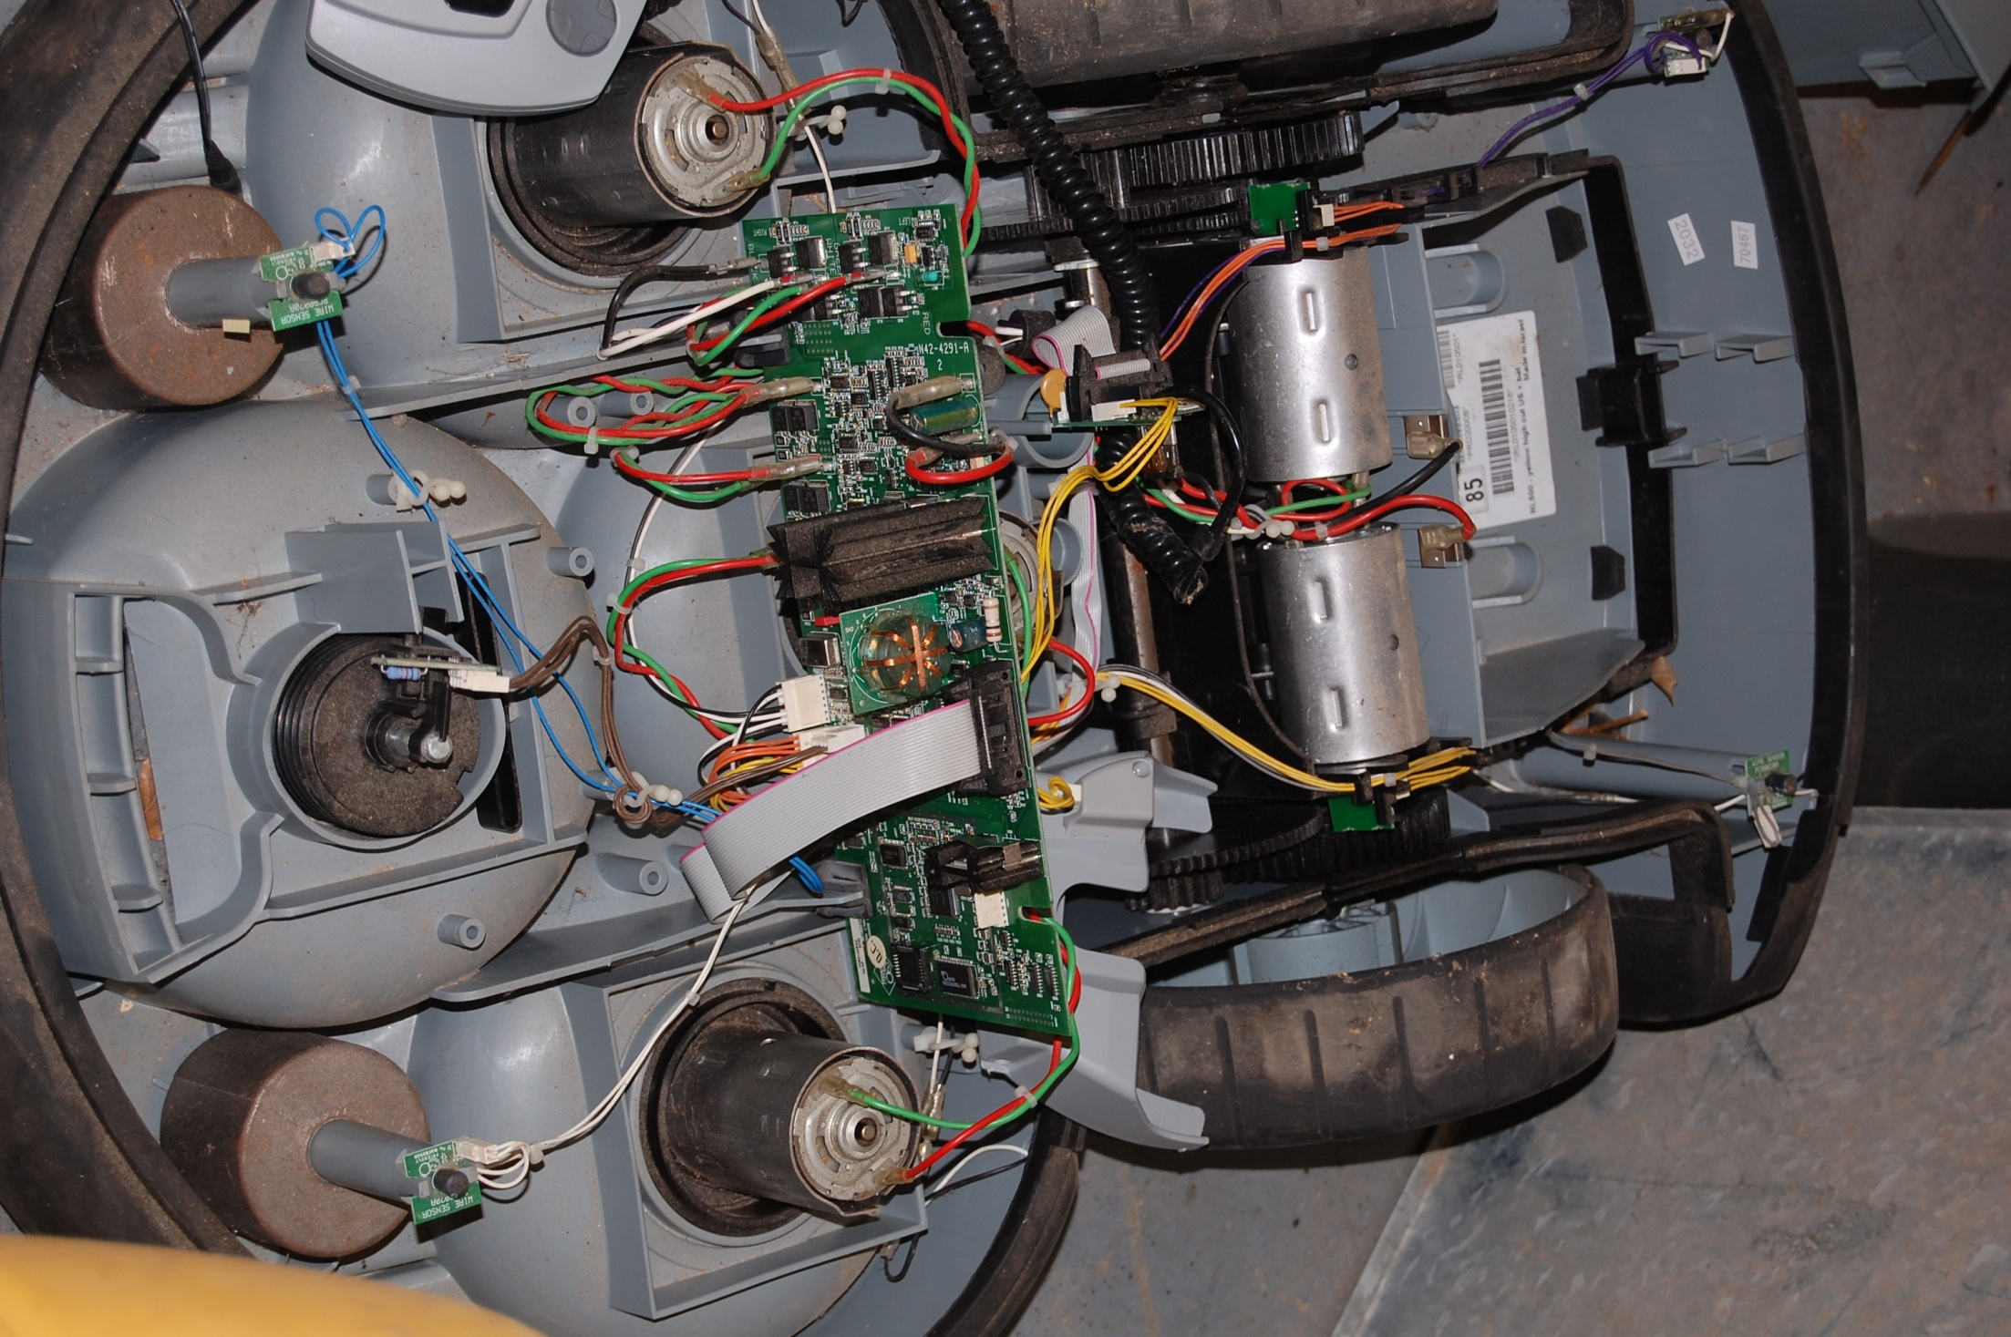
29F040 FLASH Chip
To be replaced for software upgrade
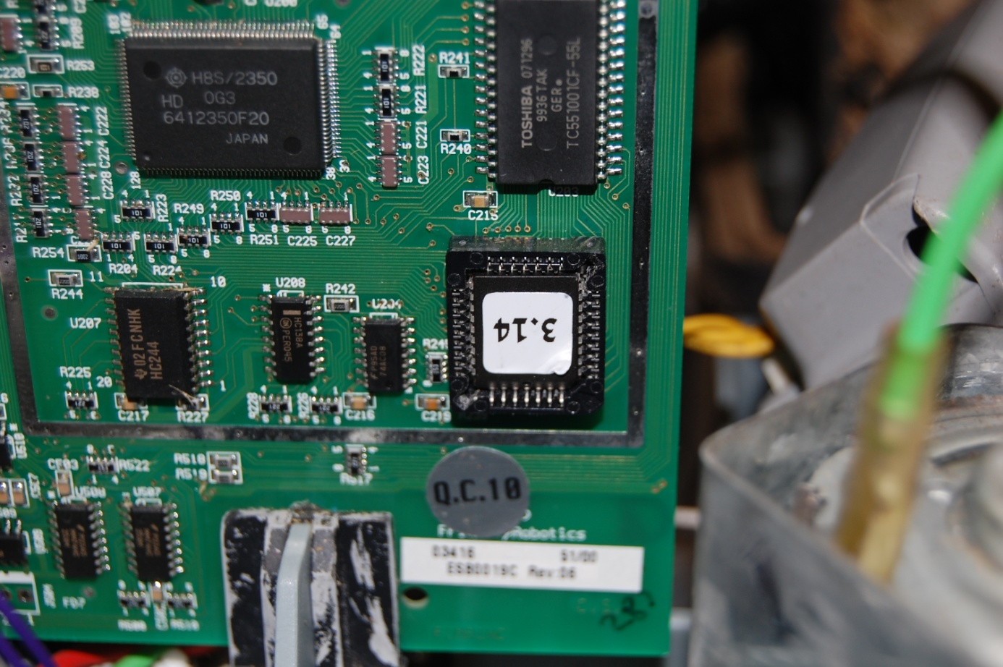
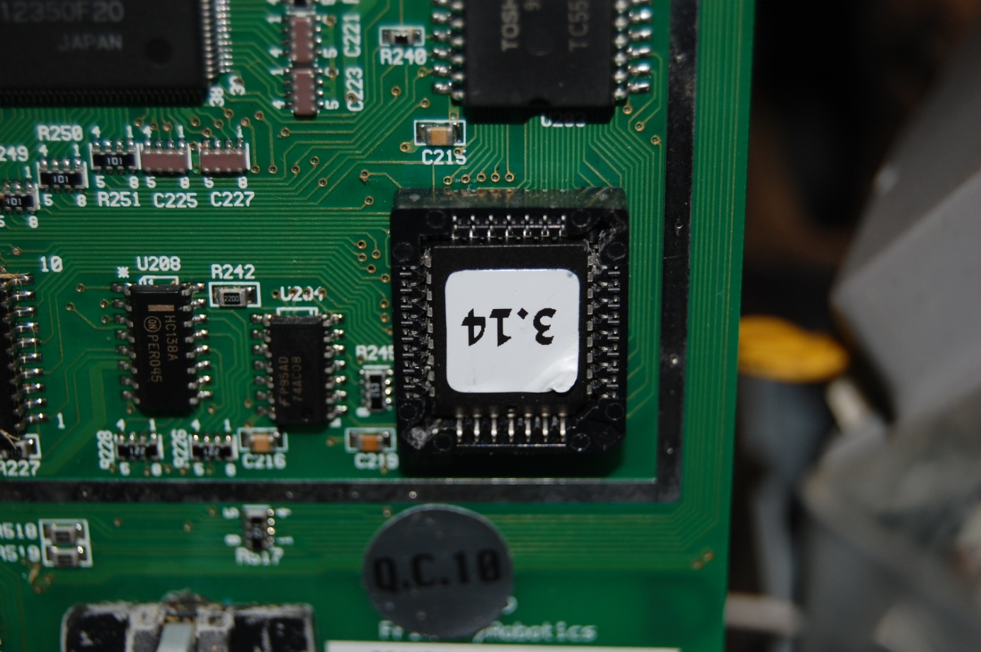
Removal slots in the corners of the flash socket. Gently pry flash from socket using a small screwdriver or nail by alternately prying each corner up

